Introduction to Digital Image Processing HW2 Report

**Name Surname**: İsmet Emir Demir

**ID**: 180315070

OS: Microsoft Windows 10 Pro Build 19042

MATLAB Version: R2020b

Octave Version: 6.2.0

Python Version: 3.9.2

Pillow Version: 8.1.2

# Assignment Details

With the help of task 1, we can see effects of intensity manipulations on images.

**Addition vs Multiplication**

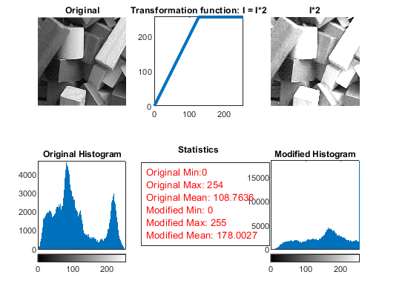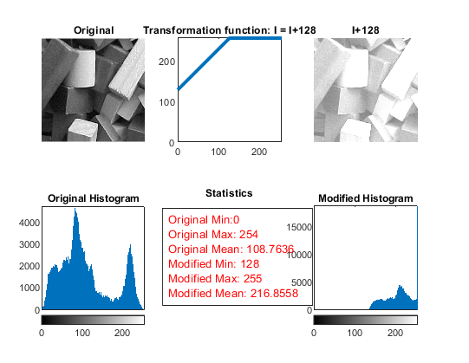When we make addition, we moved intensity values between 0-127 to 128-255 and lost details in pixels which have got intensity values more than 128. When we make multiplication, we again lost details in pixels which have got intensity values more than 128 but this time we not moved values, we extended them between 0-255. With that we achieved to keep dark pixels in image.

**Subtraction vs Division**

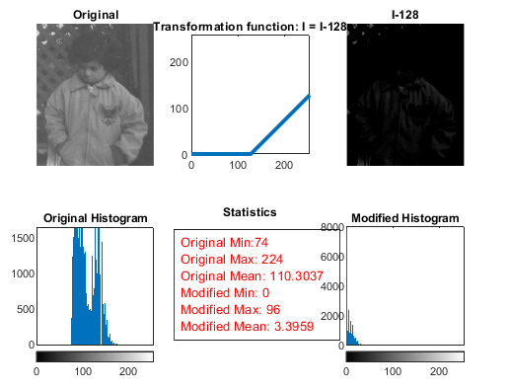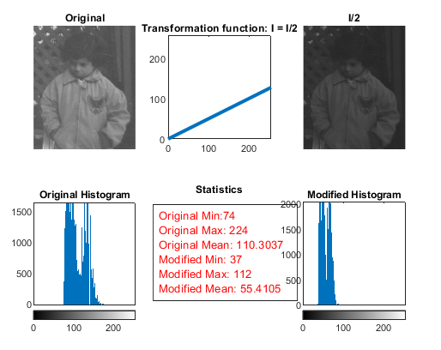 Subtraction is similar to addition. We move values between 128-255 to 0-127 and lost details in pixels which have got intensity values less than 127. But when it comes to division, we no longer lost details. We narrowing all intensity values to between 0-127.

**Negative (Complementary)**

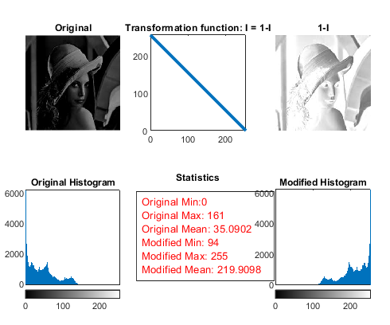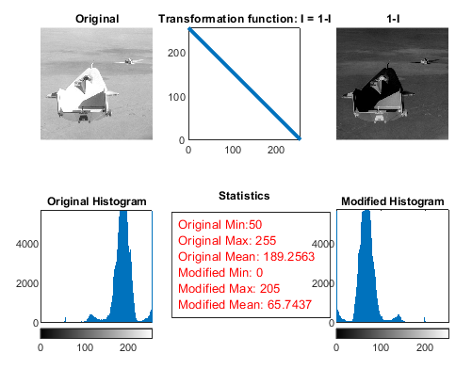 Negative version of an image is equal to difference between a white(ones) image. When we add an image to its negative version, we get white image(ones). That’s why we also call it complementary. Also, this is the reason histograms, transformation function looks reflected and mean intensity values addition is equal 255.

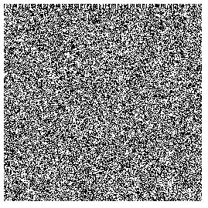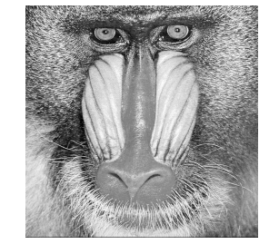Task 2 hidden message is: “One mode of failure is continually overlooking simple ideas while searching for a better way. One mode of success is continually practicing simple ideas while searching for a better way.”

# Assignment Summary

I learnt how to manipulate images by applying arithmetic operation on their intensity values. With help of histogram and statistics I was able to make inferences about effects of this operations on image. And also, I learnt how to extract an encoded message from an image and how decode it. Difficult part is converting the data to meaningful string. Conversions between data types were quite complex.